
BPP Coursework Cover Sheet
Please use the table below as your cover sheet for the 1st page of the submission. The sheet should be before the cover/title page of your submission.

Programme | MSc Management
Module name | Study for Success/Communication for Success/Skills for Success
Student Reference Number (SRN)
Report/Assignment Title | Reflective Journal: Developing Time Management and Communication Skills for Academic and Professional Success
Date of Submission
(Please attach the confirmation of any extension received)
Declaration of Original Work:
- I hereby declare that I have read and understood BPP’s regulations on plagiarism and that this is my original work, and that I have researched, undertaken, completed and submitted in accordance with the requirements of BPP School of Business.

- I declare that where I have used any AI tools, it was for the following reasons (highlight as appropriate):
  - To review a draft
  - To correct language errors
  - Other (please describe)

- I have copied & retained for BPP University’s reference, all AI prompts used in the creation of AI content and all AI-generated responses in support of my assignment and attached relevant evidence in the appendices.

- I understand that I may be required to participate in a viva voce, where I will be questioned on any aspect of my assignment, including key concepts, theories, examples used, & any sources included.

- The word count, excluding contents table, bibliography and appendices, is 2000 words.
Student Reference Number: Date:
Contents
Introduction 5
Reflective Statement 1: Time Management 5
Concrete Experience 6
Reflective Observation 6
Abstract Conceptualisation 6
Active Experimentation 7
Reflective Statement 2: Communication, Presentation, and Group Work 7
Concrete Experience 8
Reflective Observation 8
Abstract Conceptualisation 8
Active Experimentation 9
Conclusion 10
References 11

List of Figures
Figure 1: Kolb Reflective Model 5

List of Tables
Table 1: Overview of Reflective Statement 1 Using Kolb's Cycle 5
Table 2: Overview of Reflective Statement 2 Using Kolb's Cycle 7

Introduction
Reflection is considered an essential component of development in academics and the profession. In this reflection paper, there will be two reflective statements based on my experience gained in the modules of Study for Success, Communication for Success, and Skills for Success within Term 1 in the MSc Management degree. These reflections will be done by applying the Experiential Learning Cycle proposed by Kolb (1984), which includes four interlinked components: Concrete Experience, Reflective Observation, Abstract Conceptualisation, and Active Experimentation. There are two key areas of competencies that I would like to reflect upon, and these are time management, communication/presentation and group work.
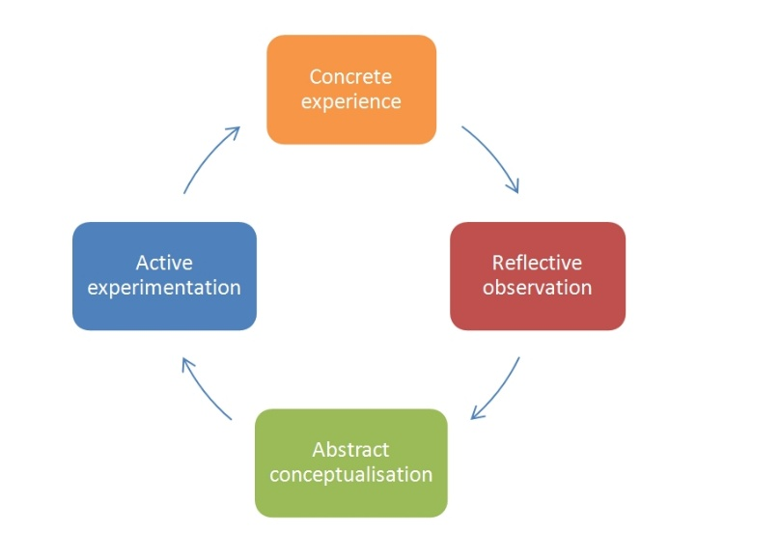
Figure 1: Kolb Reflective Model
Source: (Kolb, 1984)

Reflective Statement 1: Time Management
Table 1: Overview of Reflective Statement 1 Using Kolb's Cycle
Kolb Stage | Section | Key Content
Concrete Experience | What happened | Overwhelmed by simultaneous tasks; missed deadline; felt stressed
Reflective Observation | What I noticed | Lack of planning identified; digital tools available but unused
Abstract Conceptualisation | Theory & models | Covey (1989) matrix; Macan et al. (1990) stress-planning link
Active Experimentation | Actions taken & future plans | Weekly planning, Microsoft To Do, Pomodoro Technique

Concrete Experience
As part of my MSc coursework in the early stages, I needed to undertake a number of assignments on a variety of subjects within a week, ranging from reading tasks, discussion forums, quizzes, and writing an essay. Coming from an undergraduate background where the academic work schedule was largely teacher-led and assignments followed a sequential process, the new postgraduate course felt daunting to cope with due to the high self-management component involved. Without having developed an effective plan to deal with the tasks, I tried undertaking everything at once but did not end up finishing any of the tasks. As a result, my first written assignment was submitted one day late, causing me much anxiety and feeling ill-prepared for my academics (Faza et al., 2025).

Reflective Observation
On reflection, it became apparent that the problem I faced did not lie in the lack of effort or intelligence, but rather in my failure to adopt a methodical approach to planning. I lacked the skills to create a weekly plan, failed to order my tasks according to their importance or priority, and failed to incorporate any of the various technological tools presented to us in the Skills for Success class, namely the Outlook Calendar and Trello. It seemed that other students who handled the work load easily were those who constantly talked about planning their weeks in advance and following their own deadlines. This prompted a realization that my current ways were completely unsuited for postgraduate work in a UK university environment.

Abstract Conceptualisation
Interaction with literature helped in providing theoretical context to this experience. According to Kolb (1984), the process of experiential learning consists of four stages. Firstly, one should have a concrete experience; secondly, one should reflect on it; then, abstract concepts should be developed; and, finally, new concepts should be tested through experimenting. My experience fit the framework of the model, specifically showing how lack of reflection about old habits prevented me from experiencing effective learning.
Covey's (1989) Time Management Matrix offers an interesting theoretical concept. According to this matrix, all tasks can be grouped into four categories depending on whether the task is urgent or important and how these factors correlate. In particular, Covey argues that an effective individual spends most of his/her time doing things that fall into Quadrant II; namely, the tasks that are important but not urgent yet, such as planning ahead and mastering certain skills. Thus, my behavior in the first week of the semester was typical for Quadrant I.
Scholarly sources confirm the relationship between time management practices and achievement. Goal setting, prioritizing tasks and planning activities have been shown through extensive research to be associated with significantly reduced levels of stress among students, as well as improved academic achievements in comparison to those who did not utilize these approaches. These findings lend credibility to the behavior change that was undertaken. In addition, the use of technology to manage tasks is becoming an important skill in itself. The ability to use digital productivity tools is essential for graduates in order to increase their chances of employment, especially in roles that involve coordination of numerous work streams.

Active Experimentation
After a period of thinking and theoretical consideration, I made some adjustments in terms of my methodology. First, I started using Covey’s matrix, meaning I would categorise my tasks for each week ahead and distinguish those that had to be done immediately and others that were planned to be done later. Moreover, I used Microsoft To Do to create a list of tasks and time limits for each day of the week and Sunday evenings as a weekly fixed schedule-planning time. During two weeks, I noticed a significant change in how much control over the situation I felt and did not face any difficulties meeting my academic deadlines. Further on, I am planning to improve my use of software by testing the Pomodoro Technique, a way to work productively for a limited amount of time, divided into periods and breaks that help improve focus and avoid mental exhaustion. I am also going to ask for regular feedback from my tutors and peers to understand if my strategy is still effective under growing programme demands in future terms.

Reflective Statement 2: Communication, Presentation, and Group Work
Table 2: Overview of Reflective Statement 2 Using Kolb's Cycle
Kolb Stage | Section | Key Content
Concrete Experience | What happened | Multicultural group presentation; poor role clarity; delivery issues
Reflective Observation | What I noticed | No role allocation; cultural style differences; self-consciousness
Abstract Conceptualisation | Theory & models | Tuckman (1965); Mehrabian (1971); Claro et al. (2018)
Active Experimentation | Actions taken & future plans | English support sessions, role allocation doc, presentation practice

Concrete Experience
Towards the midpoint, I took part in a group presentation exercise in the module titled 'Communication for Success'. In this group exercise, there were four of us representing India, Nigeria, China, and the United Kingdom. We were required to prepare and deliver a presentation on the topic of professional communication in the workplace. It was my first experience of academic group work in a UK higher educational institution and it came with quite a lot of difficulties. It proved difficult to find time that all of us would be available for meetings, we had disputes about how our presentation should be done and there was no clear division of roles and responsibilities among the group members. When it was my turn to deliver my presentation, I struggled to communicate effectively as I was simply reading my notes (Au et al., 2023).

Reflective Observation
When reflecting upon the event, a number of issues came to mind that seemed to have been the cause of some of the problems. Firstly, lack of shared expectations and allocation of roles right at the start of the project resulted in unnecessary duplication of efforts, inefficiency and conflict among group members. What is more, I also noticed that the different nationalities of group members impacted our modes of communication in unexpected ways: while some group members communicated their ideas in a confident manner, others (myself included) showed restraint in case of dispute. Personally, the reasons behind the underperformance in my group tasks turned out to be my concerns about my accent and oral skills as a foreign learner of the English language.

Abstract Conceptualisation
The application of existing theories within the academic world makes understanding of the group dynamics more understandable. According to the theory advanced by Tuckman (1965), the life cycle of a group includes five stages: forming, storming, norming, performing and adjourning. It can be seen that the group has spent a greater part of time during the stage of storming, which is characterized by conflicts, lack of leadership and different perceptions among group members. Further, the theory developed by Tuckman & Jensen (1977) shows that those groups who develop common goal and clear roles in the beginning of the forming stage will more easily reach the stage of performing.
In terms of interpersonal communication, research conducted by Mehrabian (1971) about the influence of verbal and non-verbal channels in communication can provide an important theoretical foundation. According to the findings, in communicational situations where emotion plays a vital role, the channel through which the message is conveyed, namely the vocal, facial, and bodily cues, has the same amount of importance as the message itself. The use of notes in my presentation, along with my inability to establish eye contact with the audience, indicated doubtfulness and self-doubt in my case regardless of whether the information I provided was relevant or accurate. This discovery helped me re-evaluate the factors that made up good presentation skills (Trentepohl et al., 2022).
In the context of professional development, the communication and collaborative skills can be regarded as the most essential ones for employment in modern knowledge-intensive economies, especially in the highly globalized and digital environment of today's professionals. Their analysis of more than 8,000 students in several countries revealed that communication and collaboration skills were better predictors of professionalism than technical knowledge on its own. This finding reveals the importance of the development of these skills at the academic stage of one's life cycle.

Active Experimentation
Addressing the above mentioned problems, I have taken several steps, each of which would help develop the skills of communication and collaboration. In particular, I have joined the classes on academic English offered by the university, concentrating my attention on oral fluency and the language of presentations. Moreover, I started to record myself practicing my presentations via a smartphone and analyze the video focusing on pace, eye contact, and avoidance of filler language. In future group activities, I have suggested to create a Google Document where we could record our respective responsibilities and deadlines for each task within the project. As a result, the change had a positive effect on the collaboration of the group and helped eliminate the interpersonal conflicts seen earlier.
Concerning my delivery, I have focused on presenting my ideas based on notes in form of bullet points instead of a full script. At the same time, I tried to keep eye contact with different members of the audience all the time during the presentation. From feedback received from my colleagues, I conclude that such changes positively affected my confidence and clarity of speech. As for the future, I plan to attend presentations or debating clubs offered by the university, which would help me further improve my public speaking skills. Furthermore, in future work within a group, I will try to use tools such as Microsoft Teams and Miro to clearly establish roles and responsibilities from the very beginning. To evaluate my progress, I will maintain CPD log of specific improvements according to the reflective model.

Conclusion
These two reflective statements highlight the fact that time management and communication skills are learned abilities that can be improved by using reflective techniques and by applying knowledge from relevant theories. Using the Experiential Learning Cycle suggested by Kolb (1984) as a conceptual basis allows going beyond the description of one's experiences and understanding what needs to be done in order to improve oneself by referring to relevant theory. These skills (i.e. the skill of planning and prioritizing and the skill of communicating) have direct application in employability and management development.

References
Au, A., Caltabiano, N. and Oleg Vaksman (2023). The impact of sense of belonging, resilience, time management skills and academic performance on psychological well-being among university students. Cogent Education, [online] 10(1). doi: https://doi.org/10.1080/2331186x.2023.2215594.
Covey, S. (1989). THE SEVEN HABITS OF HIGHLY EFFECTIVE PEOPLE. [online] Available at: https://fulcrumglobal.us/wp-content/uploads/2019/11/Covey-The-7-habits-of-highly-effective-people.pdf.
Faza, A. and Ilyana Agri Lestari (2025). Self-Regulated Learning in the Digital Age: A Systematic Review of Strategies, Technologies, Benefits, and Challenges. The International Review of Research in Open and Distributed Learning, [online] 26(2), pp.23–58. doi: https://doi.org/10.19173/irrodl.v26i2.8119.
Kolb, D.A. (1984). Experiential Learning: Experience As The Source Of Learning And Development. [online] Research Gate. Available at: https://www.researchgate.net/publication/235701029_Experiential_Learning_Experience_As_The_Source_Of_Learning_And_Development.
Mehrabian, A. (1971). Silent Messages. [online] Available at: https://e-edu.nbu.bg/pluginfile.php/855150/mod_resource/content/1/Albert-Mehrabian%20-%20Silent%20Messages%201971%20-%20red.size.pdf.
PMI (2024). Plan Your Development to the PMI Talent Triangle | PMI. [online] Pmi.org. Available at: https://www.pmi.org/certifications/certification-resources/maintain/talent-triangle.
Trentepohl, S., Waldeyer, J., Fleischer, J., Roelle, J., Leutner, D. and Wirth, J. (2022). How Did It Get So Late So Soon? The Effects of Time Management Knowledge and Practice on Students’ Time Management Skills and Academic Performance. Sustainability, 14(9), p.5097. doi: https://doi.org/10.3390/su14095097.
Tuckman, B. (1965). Developmental Sequence in Small Groups. Psychological Bulletin, 63(6), pp.384–399. doi: https://doi.org/10.1037/h0022100.
Wilson, R., Joiner, K. and Abbasi, A. (2021). Improving students’ performance with time management skills Improving students’ performance with time management skills. Journal of University Teaching & Learning Practice Journal of University Teaching & Learning Practice, [online] 18(4). Available at: https://files.eric.ed.gov/fulltext/EJ1304142.pdf.

